Student Name | Charles Meredith
Activity Type | Hacking Web Servers and Web Applications Lab

Instructions
Perform the labs per the instructions in the iLab’s environment.
NOTE: Configure Shell GPT on Parrot OS before starting Labs
- As you complete the tasks in the lab, insert a screenshot of the steps indicated below.
- Screenshots should contain unique information generated within the VM, this should include a shell (Bash in Linux, or PowerShell in Windows) with the output of the date command and your username typed below.
- Perform all the tasks shown below. Only provide screenshots for the tasks that specify a screenshot.

Tasks and Screenshots
Complete the following lab tasks in the Hacking Web Servers iLab Module:
- Lab 1 – Footprint the Web Server
  - Task 1 – Footprint a Web Server using Net cat and Telnet
- Screenshot step 10.
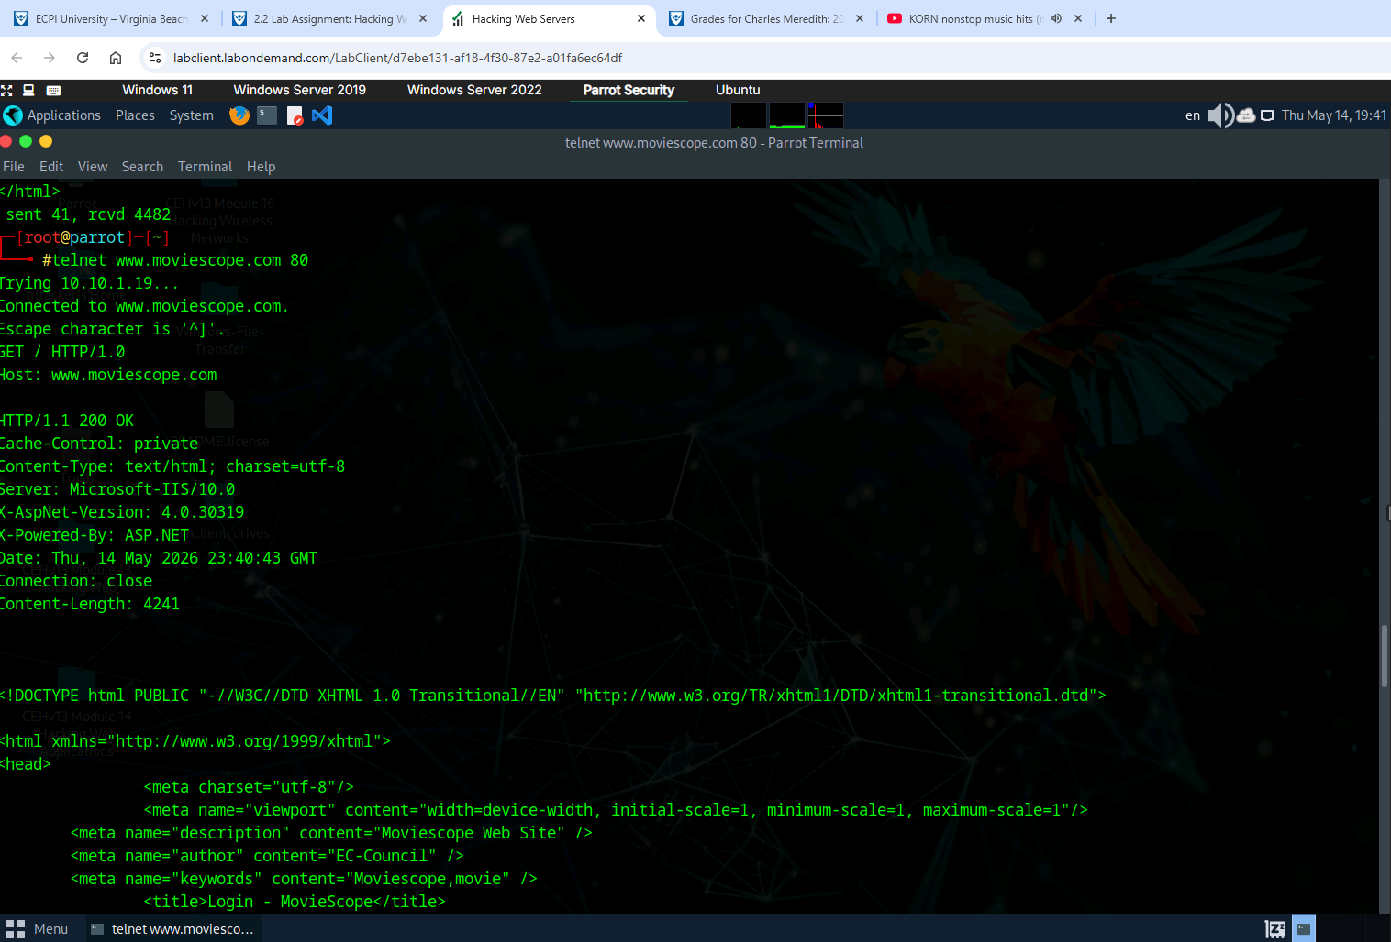
  - Task 2 – Enumerate Web Server information using Nmap Scripting Engine (NSE)
    - Screenshot step 11.
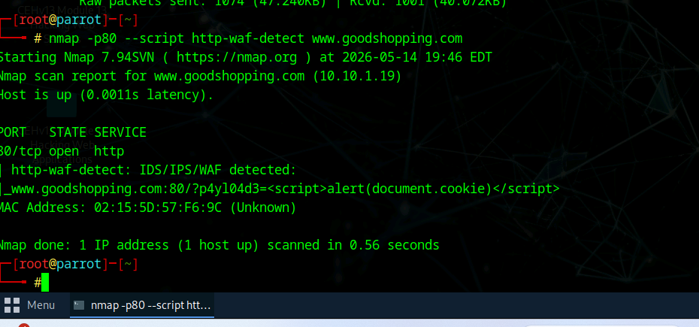

- Lab 2 – Perform a Web Server Attack
  - Task 1 – Crack FTP Credentials using a Dictionary Attack
    - Screenshot step 26.
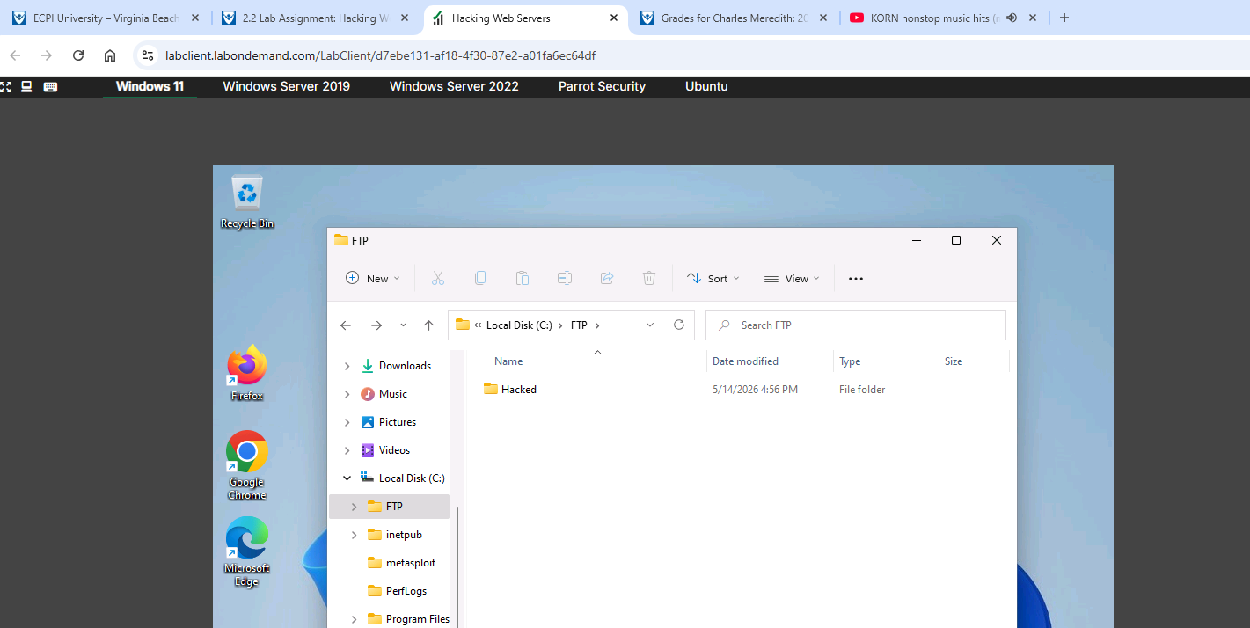
  - Task 2 – Gain Access to Target Web Server by Exploring Log4j Vulnerability
    - Screenshot step 39.
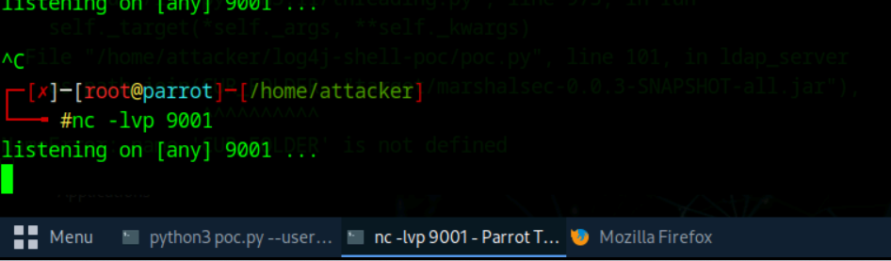
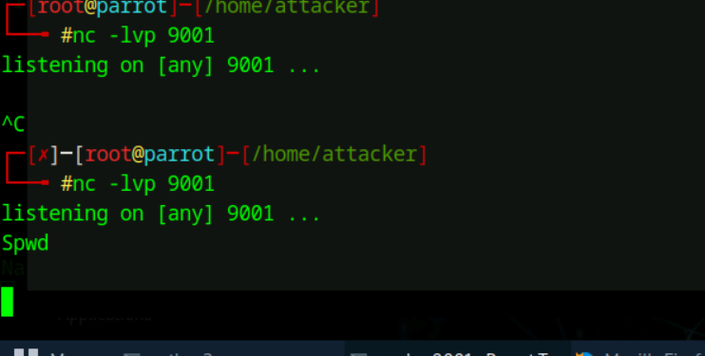
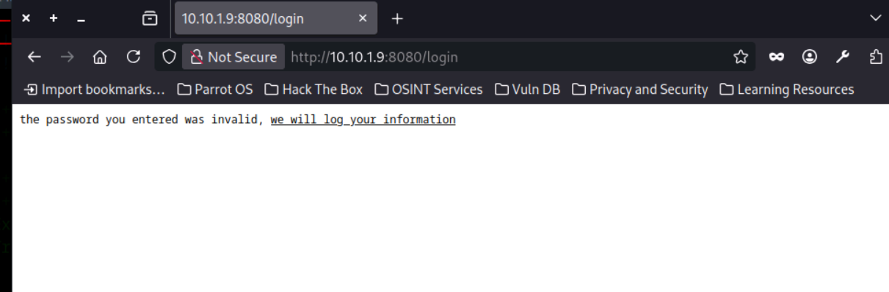
- Lab 3 – Perform a Web Server Hacking using AI
  - Task 1 – Perform Web Server Foot printing and Attacks using Shell GPT
    - Screenshot step 7.
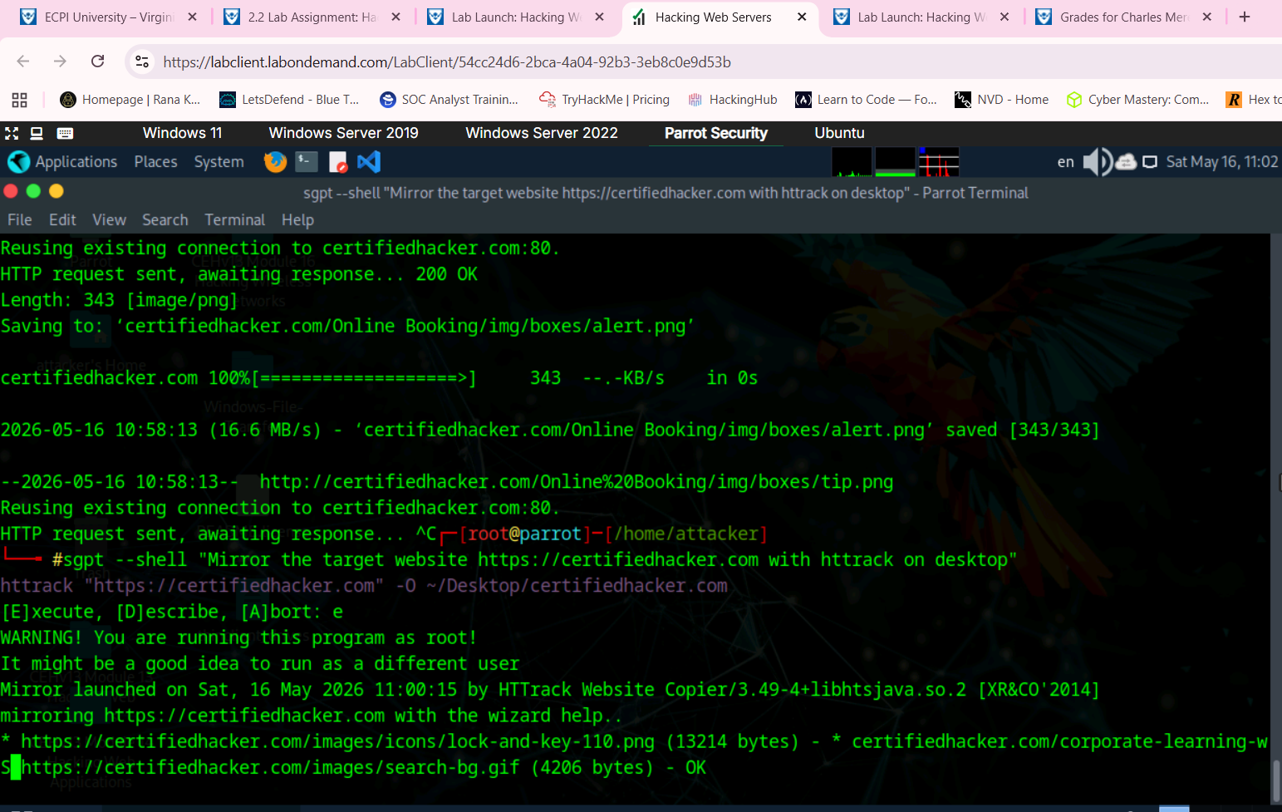
Complete the following lab tasks in the Hacking Web Applications iLab Module:
- Lab 1 – Footprint the Web Infrastructure
  - Task 1 - Perform Web Application Reconnaissance using Nmap and Telnet
    - Screenshot step 9
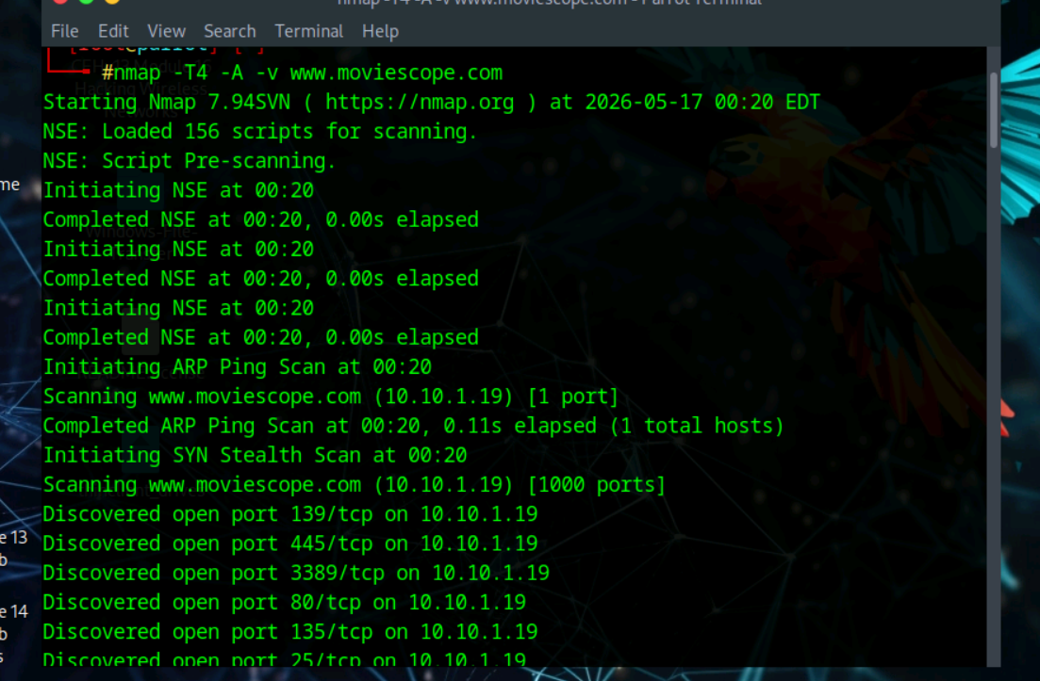
2. Screenshot step 15.

  - Task 2 - Perform Web Spidering using OWASP ZAP
1. Screenshot step 13
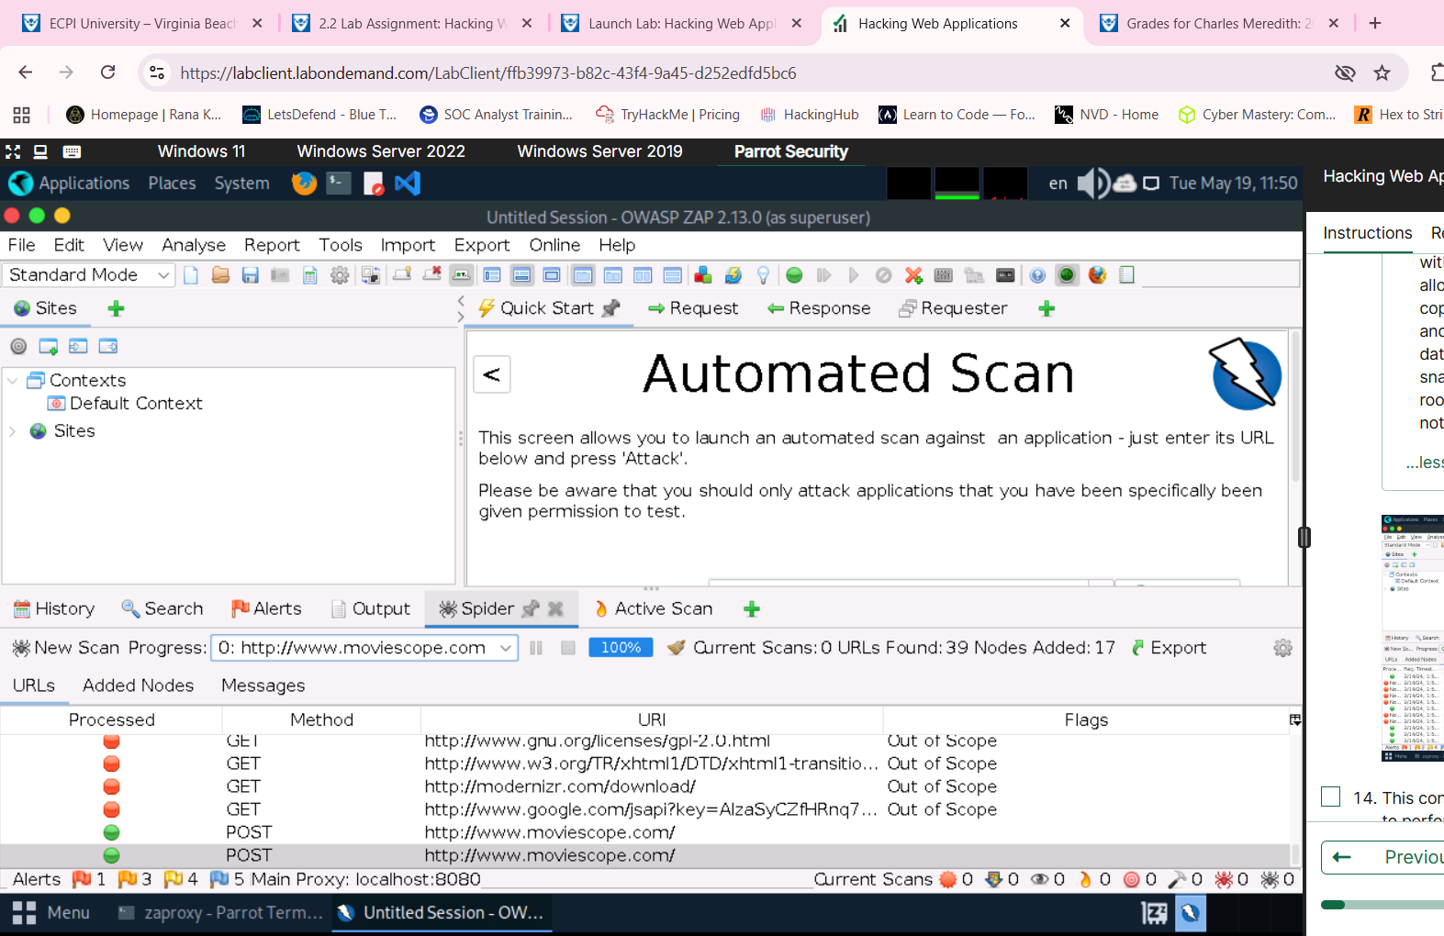
  - Task 3 – Perform Web Application Vulnerability Scanning using Smart Scanner
- Screenshot step 17.
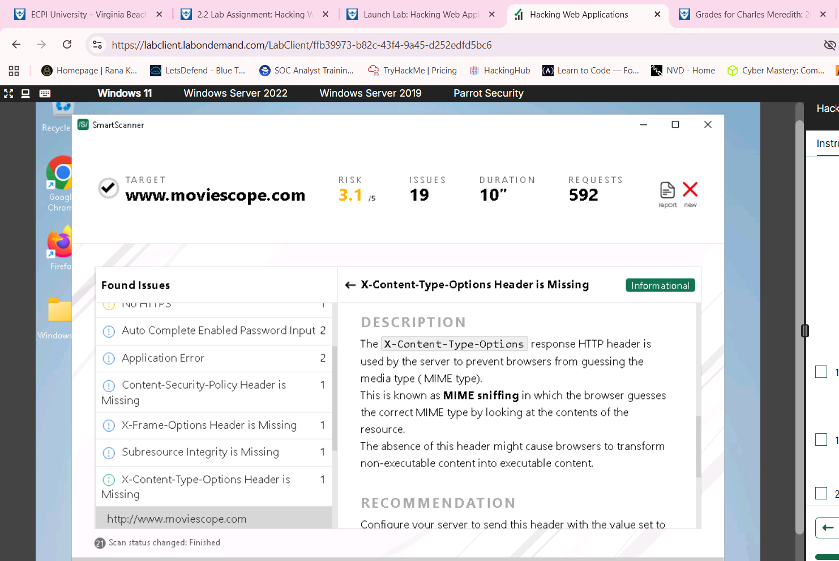
- Lab 2 - Perform web application attacks
  - Task 1 - Perform a brute-force attack using Burp Suite
1. Screenshot step 40.
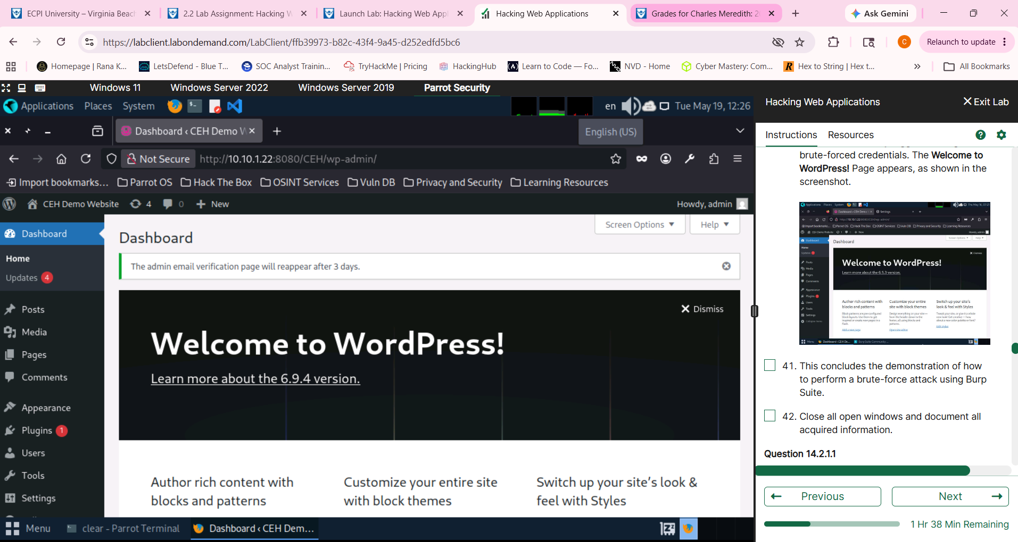
  - Task 2 - Perform Remote Code Execution (RCE) Attack
    - Screenshot step 22.
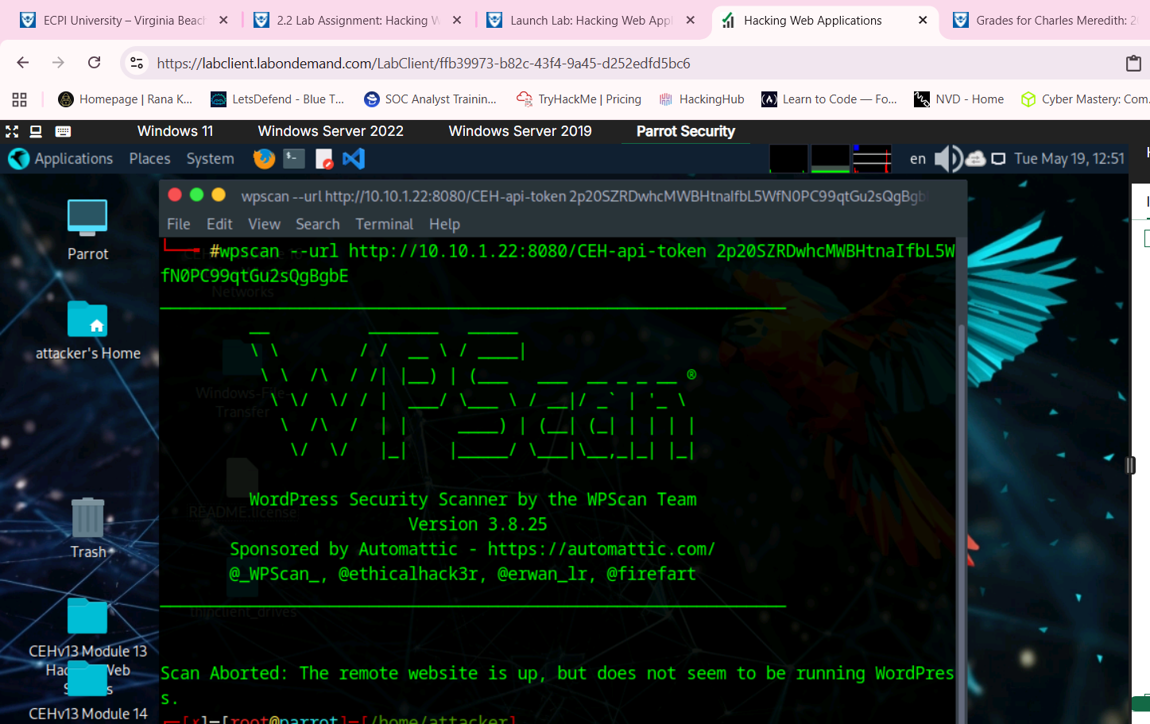
3. Lab 3- Detect Web Application Vulnerabilities using Various Web Application Security Tools
  - Task 1 - Detect Web Application Vulnerabilities using Wapiti Web Application Security Scanner
1. Screenshot step 11.
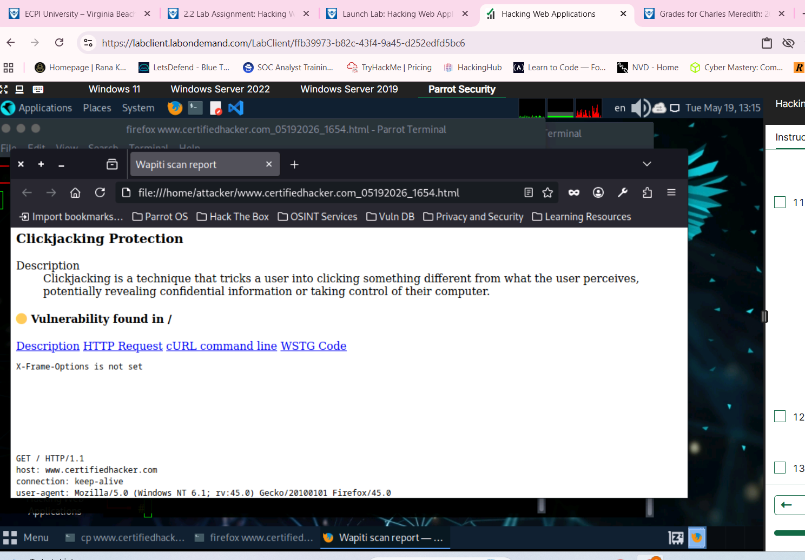

4. Lab 4- Perform Web Application Hacking AI
  - Task 1 – Perform Web Application Hacking using Shell-GPT
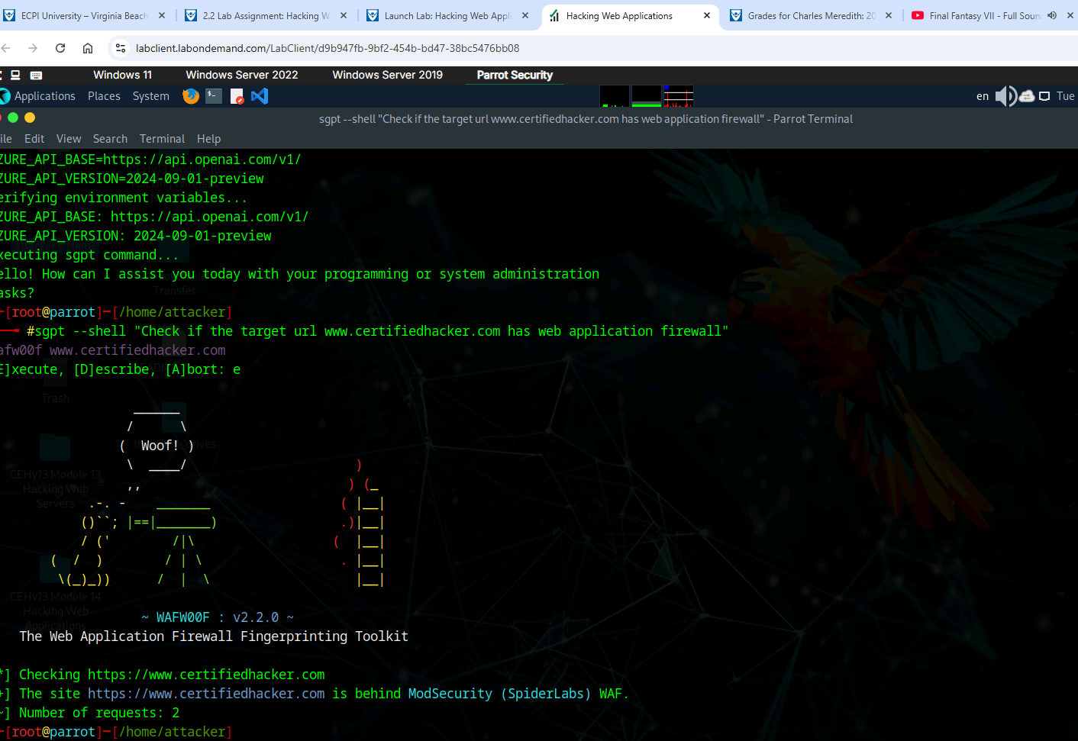

Summary
Write a few paragraphs summarizing the key skills you have acquired during this lab.
In this lab we acquired a few new key skills using many different pieces of software. For example, we used Nmap to understand if a web application firewall was up for certifiedhacker.com. We also did web application hacking using many different tools. For example, we used OWASP Zap, which is an integrated penetration testing tool to find vulnerabilities in web applications. We also used Smart scanners to match methodology to behavior. Burp suite we used to intercept and reference spider tabs to understand more about the web applications credentials.

Review Questions
Answer the following questions.
1. Attackers can exploit a poorly configured web server with Known Vulnerabilities to compromise the security of the web application.
2. What Nmap command will check whether a Web Application Firewall is configured on www.example.com?
You would run nmap -p80 --script http-waf-detect www.goodshopping.com.
3. Most password cracking techniques are successful because of weak or easy guess ability.
4. Log4J is an open-source framework that helps developers store various types of logs produced by users.
5. Web Application Hacking is the exploitation of applications via HTTP by manipulating the application logics via an application’s graphical web interface, tampering with the uniform resource identifier (URI) or HTTP elements not contained in the URI.
6. OWASP ZAP is an integrated penetration testing tool for finding vulnerabilities in web applications.
7. Smart Scanner leverages machine learning (ML) and artificial intelligence (AI) techniques to adapt its methodologies to the behavior of the target
8. Burp Suite contains key components such as an intercepting proxy, application-aware spider, advanced web application scanner, intruder tool, repeater tool, and sequencer tool.
9. This type of vulnerability is particularly dangerous because it enables attackers to take control of the target system, potentially gaining unauthorized access, stealing data, or causing damage to the system or network.
Remote Code Execution or RCE
10. The WPScan scanner identifies security weaknesses in web applications by crawling websites and performing black-box testing. It detects issues like SQL injections, XSS, and other vulnerabilities.

